**A PRELIMINARY REPORT ON**

“AUTOMATED TELLER MACHINE”

SUBMITTED TO THE EDUBRIDGE INDIA PRIVATE LIMITED

**SUBMITTED BY**

**Miss.Bhavitra Bharath Batch No: EON-5736**

**Under The Guidance of**

Amruta Deore



# DEPARTMENT OF S PRAYAS CERTIFIED JAVA FULL STACK DEVELOPER 02

**THANE**

**EDUBRIDGE INDIA PRIVATE LIMITED 2021-2022.**

**ACKNOWLEDGMENT**

It gives all of us great pleasure in presenting the preliminary project report on **“Automated Teller Machine”**. With due respect and gratitude we would like to take this opportunity to thank internal guide of our project **Mrs.Amruta Deore** for giving us all the help and guidance we needed. We are really grateful for her kind support. She has always encouraged us and given us the motivation to move ahead.She has put in a lot of time and effort in this project along with us and given us a lot of confidence. Also we wish to thank all the other people who have helped us in the successful completion of this project.

**Miss.Bhavithra Bharath**

**ABSTRACT**

Automated Teller Machine can be used by Any person to withdraw ,Deposit and check Balance in your Bank account anywhere at anytime. Achieving this objective is difficult using a manual system as it needs passbook,Chellan and we have to wait in Bank for long period of time to perform withdraw&Deposit and may be very time consuming. All these problems are solved using this project. AUTOMATED TELLER MACHINE is software which is helpful for everyone as well as the Bank to maintain record.In the activities are done manually.It is very time consuming.Our Automated Teller Machine deals with the various activities related to the Money.

**Chapter 1**

**INTRODUCTION**

* 1. **INTRODUCTION**

The objective of Automated Teller Machine allow the user of any Bank Account holder to Withdraw and Deposit Cash anywhere and at anytime and allows the user details to keep up to date in his Bank Account .It’ll also facilitate keeping all the records of User Account, such as their Pin, Name,Balance details. So all the information about their will be available and Updated in database.Overall,it’ll make withdraw and changing pin an easier job for the user . The main purpose of this SRS document is to illustrate the requirements of the project Automated Teller Machine and is intended to help any people to get easy of their bank money without going to bank .We have to used different types of module inAutomated Teller Machine.Throughout the project the focus has been on presenting information in an easy and intelligible manner.

# SCOPE

Without a Automate Teller Machine, withdrawing and Deposit of money in bank is a tedious job for an individual. Automated Teller Machine will store all the details of the user account including their Balance details and all the information related to user account .

# SYSTEM REQUIREMENTS

* + 1. **Software Requirements**

1. Operating System - Windows 10.
2. Platform - Eclipse IDE.
3. Language - Core java.
4. Files - JDK 16.0.2.

# UML DIAGRAMS

* + 1. **Use case Diagram**

The following UML use case diagram shows the working of a Automaed Teller Machine.Moreover, it has four use cases that show the particular functionality of the Automated Teller Machine of individual User Account. The four use cases are; Check user account and password, Withdraw money, Deposit Money,Check Balance,change user pin.The interactions of the User and ATM are what sum up the Automated Teller Machine use case diagram example.

/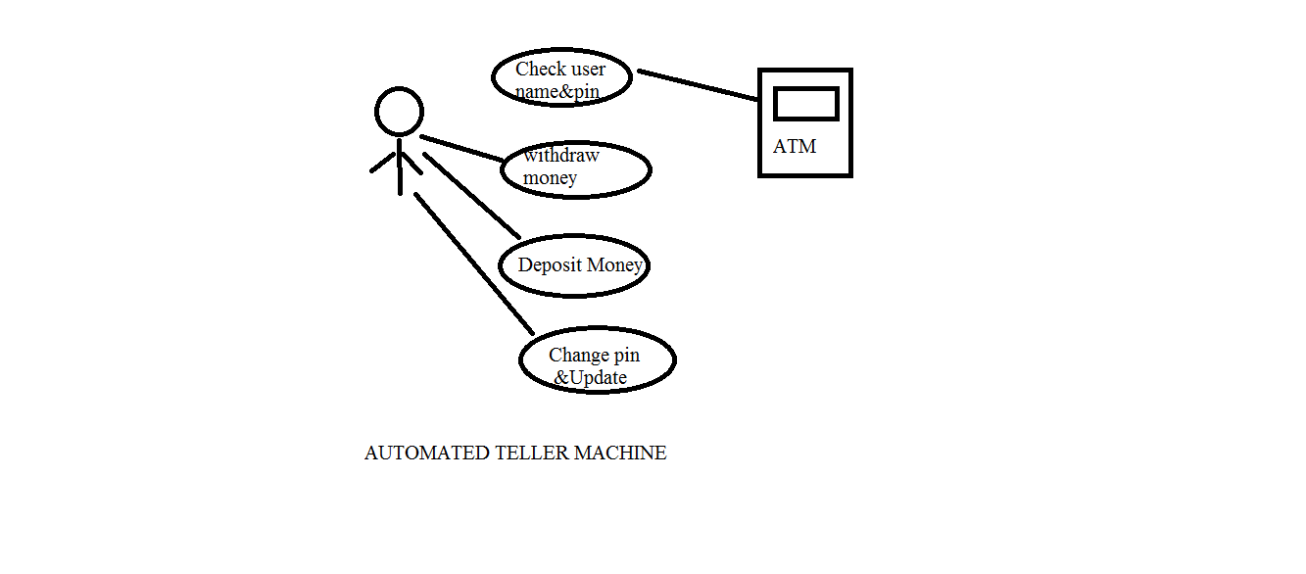

# MODULE

* + 1. **Login**

Login module will help in authentication of user accounts .Users who have valid login id and pin can only login into their respective accounts

**void** enter()

{

System.***out***.println("ENTER USERNAME: ");

*usname*=sc.next();

System.***out***.println("ENTER pin: ");

*p*=sc.nextInt();

}

**void** validate(String username,**int** pin) **throws** ClassNotFoundException, SQLException

{

**try**

{

Class.*forName*("com.mysql.cj.jdbc.Driver");

Connection con = DriverManager.*getConnection*("jdbc:mysql://localhost:3306/atmtransaction?autoReconnect=true&useSSL=false","root","root");

PreparedStatement ps = con.prepareStatement("select * from user");

ResultSet rs = ps.executeQuery();

**while**(rs.next())

**while**(rs.getInt("pin")==*p* &&rs.getString("username").equals(*usname*))

{

System.***out***.println("chosse any one operation:");

System.***out***.println("Choose 1 for Withdraw");

System.***out***.println("Choose 2 for Deposit");

System.***out***.println("Choose 3 for Check Balance");

System.***out***.println("Choose 4 for to change pin");

System.***out***.println("Choose 5 to exit");

System.***out***.print("Choose the operation you want to perform:");

**int** n = sc.nextInt()

**switch**(n)

# Withdraw

This module will help the user get money from ATM at anywhere if internet is present

This module will really simplify the task of chellan. Also after successful withdraw user can update and can see available balance.

**int** withdraw,bal;

System.***out***.print("Enter money to be withdrawn:");

withdraw = sc.nextInt();

**if**(rs.getInt(3)>= withdraw)

{

bal = rs.getInt(3) - withdraw;

System.***out***.println("YOUR TRANSACTION IS BEING PROCESSED");

System.***out***.println("Please collect your money Thankyou!!");

PreparedStatement smt = con.prepareStatement("UPDATE user SET balance=? WHERE username=?");

smt.setInt(1,bal);

smt.setString(2, *usname*);

smt.executeUpdate();

System.***out***.println("Available balance: "+bal);

System.***out***.println("THANKYOU HAVE A GOOD DAY");

System.*exit*(0);

}

**else**

{

System.***out***.println("Insufficient Balance");

System.*exit*(0);

}

**break**;

# Deposit

To deposit money of the User in their respective Bank account

**case** 2:

**int** depo,baal;

Scanner sca = **new** Scanner(System.***in***);

System.***out***.print("Enter money to be deposited:");

depo = sca.nextInt();

baal= depo + rs.getInt(3);

PreparedStatement ssmtt = con.prepareStatement("UPDATE user SET balance=? WHERE username=?");

ssmtt.setInt(1,baal);

ssmtt.setString(2, *usname*);

ssmtt.executeUpdate();

System.***out***.println("Your Money has been successfully depsited");

System.***out***.println("Available balance: "+baal);

System.***out***.println("THANKYOU HAVE A GOOD DAY");

System.*exit*(0);

**break**;

# Change Pin and Check Balance

User can change their pin if it is required and also can check balance at anytime in the ATM

System.***out***.println("Balance : "+rs.getInt(3));

System.***out***.println("THANKYOU HAVE A GOOD DAY");

System.*exit*(0);

**break**;

**case** 4:

System.***out***.println("Enter USERNAME: ");

*usname*=sc.next();

System.***out***.println("Enter CURRENT PIN NUMBER: ");

*p*=sc.nextInt();

System.***out***.println("Enter NEW PIN NUMBER: ");

*pn*=sc.nextInt();

Class.*forName*("com.mysql.cj.jdbc.Driver");

Connection conn = DriverManager.*getConnection*("jdbc:mysql://localhost:3306/atmtransaction?autoReconnect=true&useSSL=false","root","root");

**if**(rs.getInt("pin")==*p* && rs.getString("username" ).equals(*usname*))

{

PreparedStatement smtt = conn.prepareStatement("UPDATE user SET Pin=? WHERE username=?");

smtt.setInt(1,*pn*);

smtt.setString(2, *usname*);

smtt.executeUpdate();

System.***out***.println("PIN NUMBER SUCCESSFULLY CHANGED");

System.***out***.println("THANKYOU HAVE A GOOD DAY");

System.*exit*(0);

}

**else** {

System.***out***.println("YOU ENTERED CURRENT PIN OR USERNAME WRONGLY TRY AGAIN!!!");

System.*exit*(0);

}

**break**;

**case** 5:

System.***out***.println("Thankyou!!!!");

**break**;

}

}

{

# ADVANTAGES

* Easy Access
* Can use Atm anywhere and at anytime
* Easy Data Management

**Chapter 2**

**PROJECT IMPLEMENTATION**

* 1. **SCREENS**

**Login page**

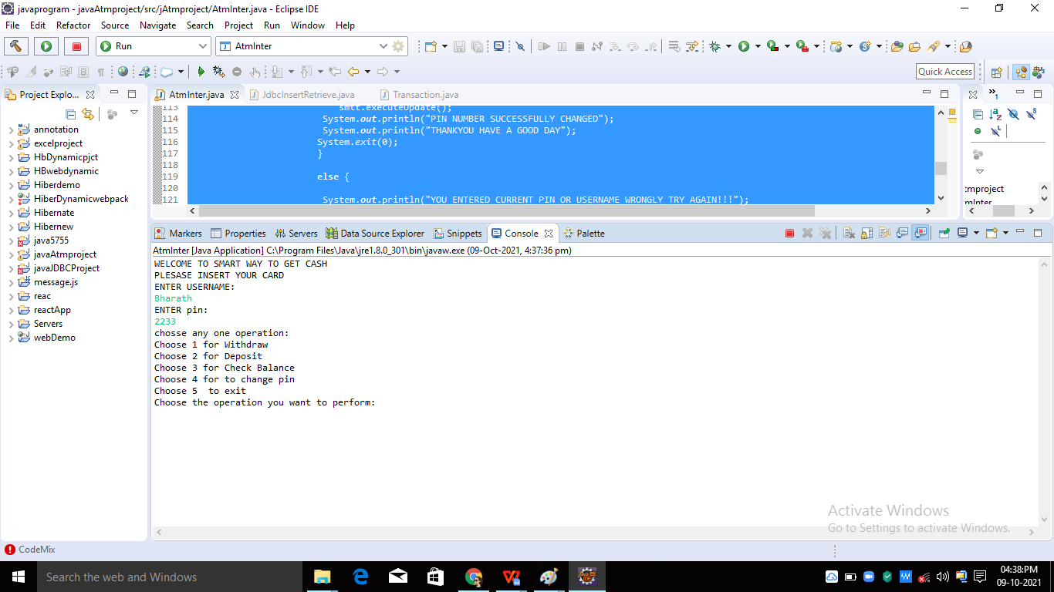

* 1. **SCREENS**

**Withdraw**

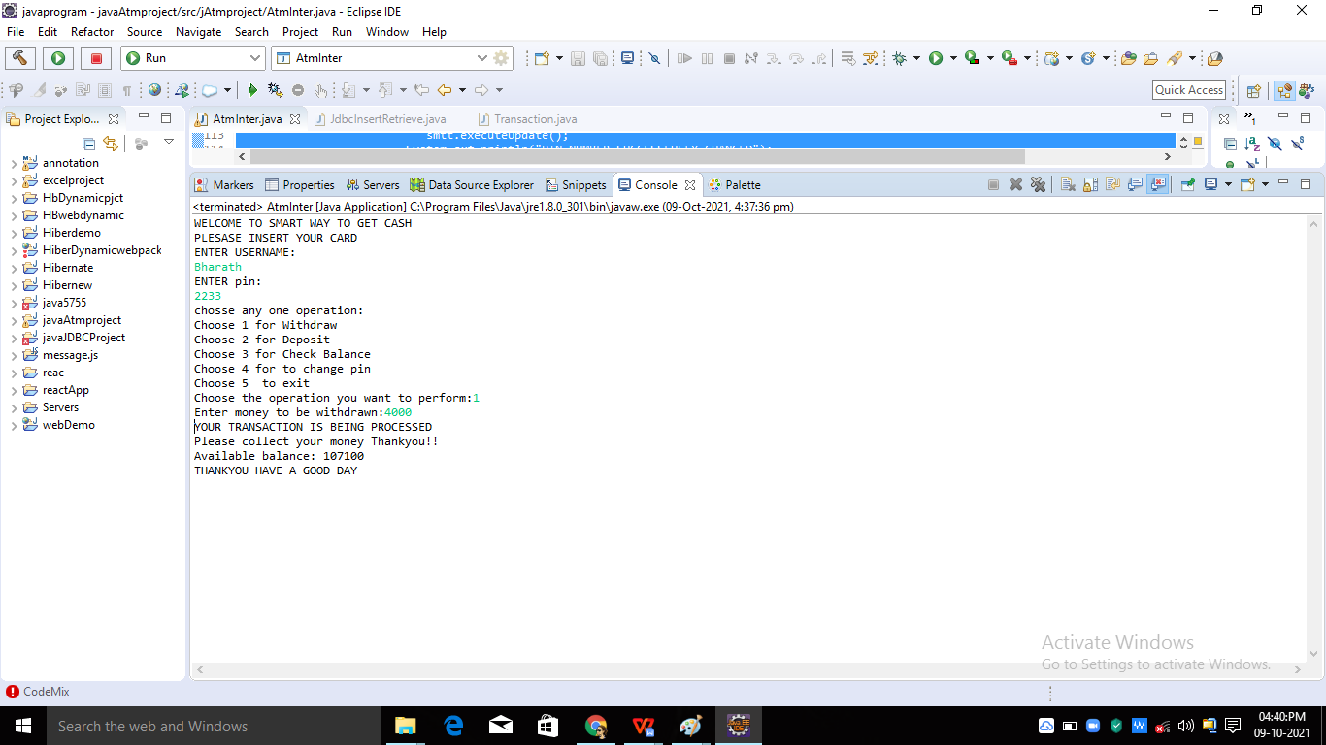

* 1. **SCREENS**

**Deposit**

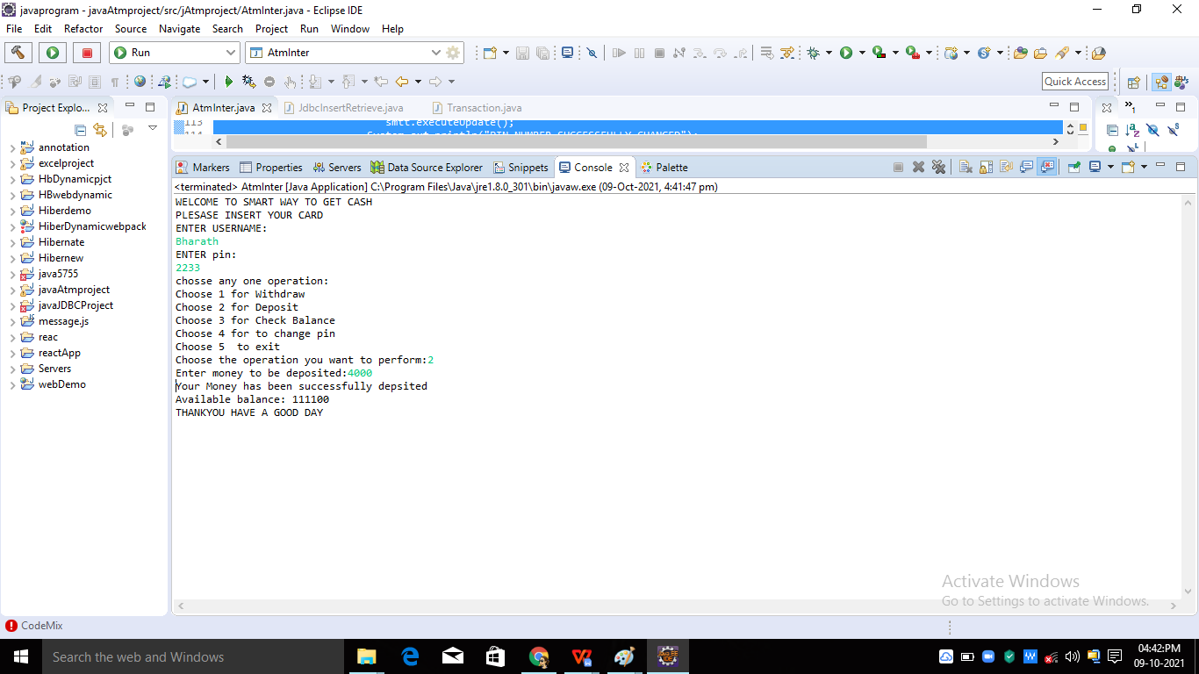

* 1. **SCREENS**

**Change Pin**

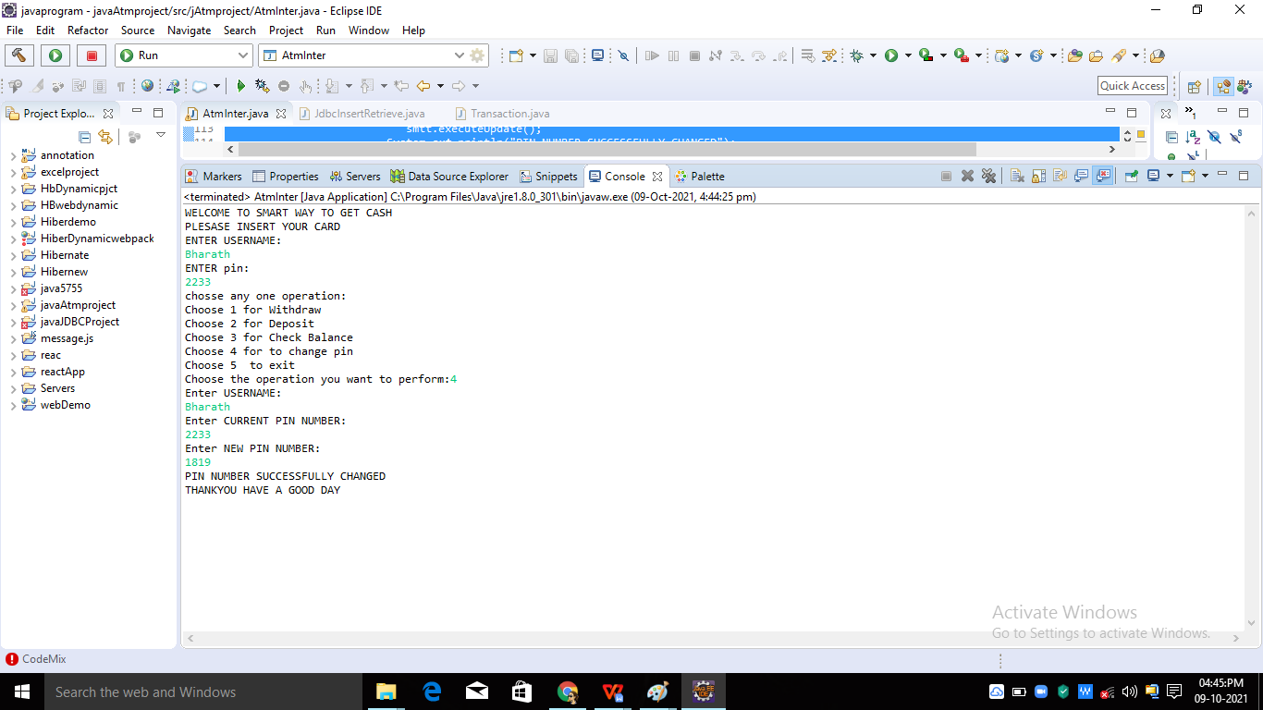

**2.5 Screens**

**Check Balance**

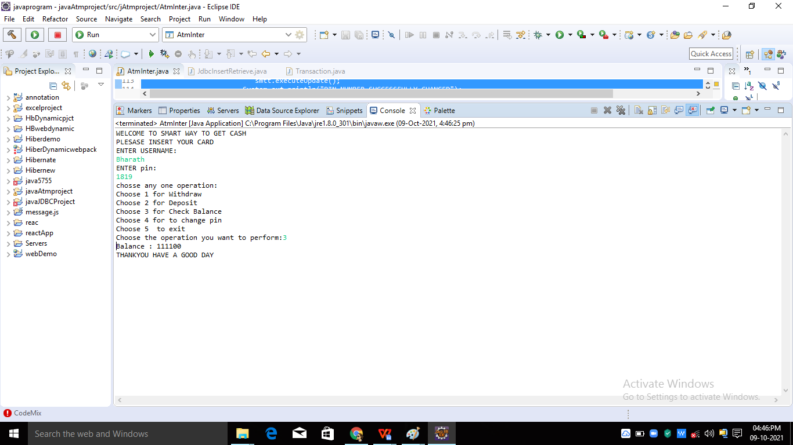

**Chapter 3**

**CONCLUSIONS**

**3.1CONCLUSIONS**

Automated Teller Machine can be used by any individual who have Bank account to withdraw,deposit money easily.Achieving this objective is difficult by going bank as it has long procedure to access our Account information and may be very time-consuming. All these problems are solved by this project.